اﻟﺴﻴﺮة اﻟﺬاﺗﻴﺔ CV

البيانات الشخصية

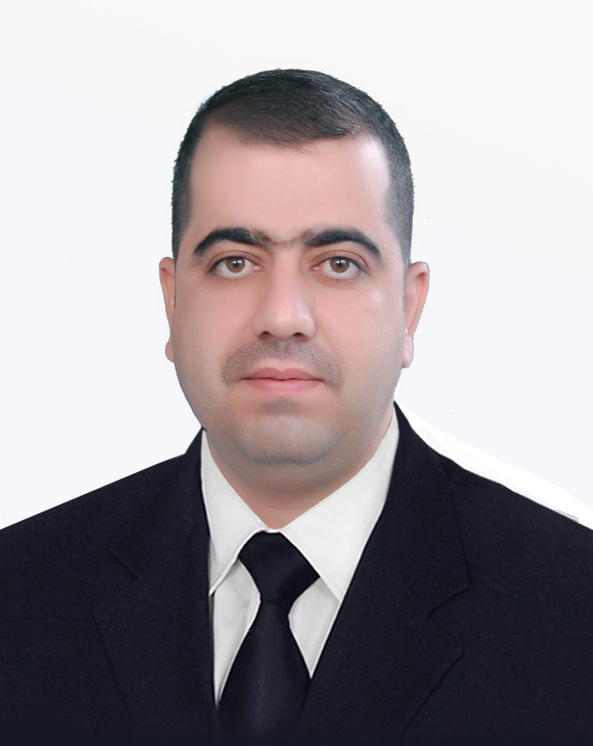
ﺧﺻﻳﺔ

ﺍﻻﺳﻡ | : مجيد احمد ولي
ﻣﺣﻝ ﻭﺗﺎﺭﻳﺦ ﺍﻟﻭﻻﺩﺓ | : | بغداد- 1978
ﺍﻟﺟﻧﺱ | : | ﺫﻛﺭ
ﺍﻟﺣﺎﻟﺔ ﺍﻟﺯﻭﺟﻳﺔ | : | ﻣﺗﺯﻭﺝ
ﺍﻟﻠﻐﺎﺕ ﺍﻟﺗﻲ ﻳﺗﻘﻧﻬﺎ | : العربية والانكليزية
ﺍﻟﺟﻧﺳﻳﺔ ﻭﺍﻟﻘﻭﻣﻳﺔ | : | ﻋﺭﺍقي-عربي
ﻋﻧﻭﺍﻥ ﺍﻟﻌﻣﻝ | : | ﺟﺎﻣﻌﺔ ﺑﻐﺩﺍﺩ ﻛﻠﻳﺔ ﺍﻟﺗﺭﺑﻳﺔ للعلوم الصرفة (ﺍﺑﻥ ﺍﻟﻬﻳﺛﻡ) / ﻗﺳﻡ الرياضيات

ﺍلالقاب العلمية

استاذ 2020

استاذ مساعد 2015

مدرس 2012

مدرس مساعد 2005
ااال
استاذذا

ﺍﻟﺷﻬﺎﺩات والدورات
ﺍﻟﺷﻬﺎﺩﺍﺕ ﻭﺍﻟﺩﻭﺭﺍﺕشهاد

الشهادة السنة الجهة المانحة
بكلوريوس علوم رياضيات 2000 جامعة بغداد كلية التربية ابن الهيثم
ماجستير علوم رياضيات 2005 جامعة بغداد كلية التربية ابن الهيثم
دكتوراه علوم رياضيات (التحليل العددي) 2012 جامعة برونيل-انكلترا- لندن

الدورات

1- اجتياز امتحان كفاءة اللغة الانكليزية جامعة بغداد (2002).
2- دورة الكفاء في استخدام الحاسوب جامعة بغداد –التربية ابن الهيثم (2002).
3- اجتياز امتحان الايلتس من جامعة برونيل البريطانية بعد كورس اللغة (2008).
4- اجتياز دورة تعلم اللاتكس من جامعة برونيل –انكلترا- لندن (2011).
5- دورة التاهيل التربوي واللغة العربية (2015)
6- دورة اللغة العربية (2018).

السيرة الادارية
رئيس قسم الرياضيات 2014-2018
معاون العميد للشؤون العلمية والدراسات العليا 21-7-2022- لحد الان
المواد الدراسية التي درستها

التحليل العقدي المرحلة الرابعة 2000-2001
المعادلات التفاضلية الاعتيادية المرحلة الثانية 2018-2019و2006-2008
التحليل العددي المرحلة الثالثة 2012-2014
المعادلات التكاملية الماجستير 2014-2020
المعادلات التفاضلية الاعتيادية والجزئية الماجستير 2015-2020
المعادلات التفاضلية والتكاملية الدكتوراه 2018-2020
المعادلات التفاضلية الجزئية المرحلة الثالثة 2019-2020
حلول المعادلات الدكتوراه 2019-2020
حلول المعادلات التفاضلية والتكاملية الدكتوراه 2020-2022
المهارات البرمجية

جيد في
MATLAB, MATHEMATICA, MAPLE and LATEX.

الاطاريح والاشراف
- Majeed Ahmed “The radial integration boundary integral and integro-differential equation methods for numerical solution of problems with variable coefficients”, PhD thesis, Brunel University, London, UK, 2012.
Available at:

http://bura.brunel.ac.uk/handle/2438/6449

- Majeed Ahmed “Numerical Methods For System of Integral Equations”,M.Sc. thesis, Baghdad University, Baghdad, Iraq.

الاشراف
الماجستير 12 طالب وطالبة تمت المناقشة.وطالب دكتوراه في الاشراف حاليا.

البحوث المنشورة في مجلات عالمية ذات عامل التاثير

البحوث المنشورة
البحوث المنشورة في مجلات عالمية ذات معامل التاثيرضمن تصنيف كلارفيت / سكوبس

- M.A. AL-Jawary and L.C. Wrobel. Numerical solution of two-dimensional mixed problems with variable coefficients by the boundary-domain integral and integro-differential equation methods, Engineering Analysis with Boundary Elements, 35:1279-1287; 2011.

- M.A. AL-Jawary and L.C.Wrobel. Radial integration boundary integral and integro-differential equation methods for two-dimensional heat conduction problems with variable coefficients, Engineering Analysis with Boundary Elements, 36:685-695;2012.

- M.A. AL-Jawary and L.C. Wrobel. Numerical solution of the two-dimensional Helmholtz equation with variable coefficients by the radial integration boundary integral and integro-differential equation methods. International Journal of Computer Mathematics, Vol. 89, No. 11, July 2012, 1463–1487.

- M.A. AL-Jawary, J. Ravnik, L.C. Wrobel and L. Skerget. Boundary element formulations for numerical solution of two-dimensional diffusion problems with variable coefficients. Computers and Mathematics with Applications, Volume 64, Issue 8, October 2012, 2695-2711.

- M. A. AL-Jawary and H. R. AL-Qaissy, A reliable iterative method for solving Volterra integro-differential equations and some applications for the Lane–Emden equations of the first kind, MNRAS 448, 3093–3104 (2015), Monthly Notices of the Royal Astronomical Society, I.F 5.107.

- M. A. Al-Jawary, R. K. Raham, G. H .Radhi, An Iterative Method For Calculating Carbon Dioxide Absorbed Into Phenyl Glycidyl Ether, J. Math. Comput. Sci. 6 (2016), No. 4, 620-632.

- M. A. AL-Jawary , S. G. AL-Razaq, A semi analytical iterative technique for solving Duffing equations, International Journal of Pure and Applied Mathematics,108(2016) 871-885.

- M. A. AL-Jawary, R. K.Raham, A semi-analytical iterative technique for solving chemistry problems, Journal of King Saud University – Science (2017) 29, 320–332.

- M.A.AL-Jawary, An efficient iterative method for solving the Fokker-Planck equation, Results in Physics 6 (2016) 985–991.

- Majeed Ahmed AL-Jawary ,Ghassan Hasan Radhi ,Jure Ravnik, Boundary-domain integral method and homotopy analysis method for systems of nonlinear boundary value problems in environmental engineering, Arab Journal of Basic and Applied Sciences, 27:1(2020) 121-133.

- M. A. Al-Jawary, G. H. Radhi, Jure Ravnik, Two efficient methods for solving Schlömilch’s integral equation , International Journal of Intelligent Computing and Cybernetics, 2017, Vol. 10 Issue: 3, pp.287-309.

- M. A. Al-Jawary, A semi analytical iterative method for solving nonlinear thin film flow problems, Chaos, Solitons & Fractals 99 (2017) 52–56.

- Majeed Ahmed AL-Jawary and Sinan Hatif, A semi-analytical iterative method for solving differential algebraic equations, Ain Shams Engineering Journal, Volume 9, Issue 4, December 2018, Pages 2581-2586.
- M. A. Al-Jawary, Mustafa Mahmood Azeez, G. H. Radhi, Analytical and numerical solutions for the nonlinear Burgers and advection–diffusion equations by using a semi-analytical iterative method. Computers and Mathematics with Applications Volume 76, Issue 1, 1 July 2018, Pages 155-171.

- M. A. Al-Jawary, G. H. Radhi, Jure Ravnik, A Semi-Analytic Method for Solving Fokker-Plank Equations, Journal of the Association of Arab Universities for Basic and Applied Sciences, Volume 24, October 2017, Pages 254-262.

- M. A. Al-Jawary, G. H. Radhi, Jure Ravnik, Daftardar-Jafari Method for Solving Nonlinear Thin Film Flow Problem, Journal of the Association of Arab Universities for Basic and Applied Sciences, Journal Arab Journal of Basic and Applied Sciences, Volume 25, 2018 - Issue 1, 20-27.

- M. A. Al-Jawary, G. H. Radhi, Jure Ravnik, Development of the Banach contraction method for the solution of nonlinear thin film flows of non-Newtonian fluids, Journal Arab Journal of Basic and Applied Sciences, Volume 25, 2018 - Issue 3, 122-131.
- Abdul Nabi, A. J. and AL-Jawary, M.A., 2018. Analytical and Numerical Solutions for the Linear and Nonlinear 1D, 2D and 3D Telegraph Equations. Journal of Advanced Research in Dynamical and Control Systems, 10(10-Special Issue), pp. 2090-2105.

- Al-Jawary, M.A., Adwan, M.I. and Radhi, G.H., Three iterative methods for solving second order nonlinear ODEs arising in physics. Journal of King Saud University-Science, 23 (2020) 312-323.

- Majeed A. AL-Jawary and Othman M. Salih, Reliable iterative methods for 1D Swift–Hohenberg equation, Arab Journal of Basic and Applied Sciences, 27:1(2020) 56-66.

- M. I. Adwan, M. A. Al-Jawary, J. Tibaut and J. Ravnik, Analytic and numerical solutions for linear and nonlinear multidimensional wave equations, Arab Journal of Basic and Applied Sciences, 27:1(2020) 166-182.
- M. A. Al-Jawary, Ghada H. Ibraheem , Two Meshless Methods for Solving Nonlinear Ordinary Differential Equations in Engineering and Applied Sciences, Nonlinear Engineering (2020) 9: 244–255.

- M. A. Al-Jawary, Ghada H. Ibraheem , The operational matrix of Legendre polynomials for solving nonlinear thin film flow problems, Alexandria Engineering Journal, 59, 4027-4033, 2020.

- Majeed Ahmed Weli, AL-Zahraa J. Abdul Nabi, Reliable iterative methods for solving convective straight and radial fins with temperature-dependent thermal conductivity problems, Gazi University Journal of Science, 32(3),967-989, 2019.

- Majeed Ahmed Weli, AL-Zahraa J. Abdul Nabi, Three iterative methods for solving Jeffery-Hamel flow problem, Kuwait Journal of Science, 47:1(2020)1-13.

- Sawsan Mohsin Abed, M.A. AL-Jawary, Efficient Iterative methods for solving the SIR Epidemic Model, Iraqi Journal of Science, 62(2) 613-622 2021.

- Sawsan Mohsin Abed, M.A. AL-Jawary, Reliable Iterative Methods for Mathematical Biology Model, Communications in Mathematical Biology and Neuroscience (2020) 2020:45.

- Sawsan Mohsin Abed, M.A. AL-Jawary, Reliable Iterative Methods For Mathematical Model Of Covid-19 Based On Data In Anhui, China, Communications in Mathematical Biology and Neuroscience (2020) 2020:50.

- Majeed Ahmed Weli, Montaser I. ADWAN, Reliable Iterative Methods for Solving the Falkner-Skan Equation, Gazi University Journal of Science, 33(1),168-186, 2020.
- Othman M. Salih, Majeed A. AL-Jawary, Reliable Iterative Methods for Solving 1D, 2D and 3D Fisher’s Equation, IIUM Engineering Journal, 22, 138-166, 2021.
- Areej Salah Mohammed, Majeed Ahmed AL-Jawary, Three Weighted Residuals Methods for Solving the Nonlinear Thin Film Flow Problem. Journal of Physics: Conference Series, 1879(2021)022096.
- Amna M. Mahdi, Majeed A. Al-Jawary, the operational matrices methods for solving Falkner-Skan equations, Iraqi Journal of Science (In press).
- Amna M. Mahdi, Majeed A. Al-Jawary, Efficient computational methods for solving the nonlinear initial and boundary value problems, American Institute of Physics (AIP Conference Proceedings) (In press).
- Amna M. Mahdi, Majeed A. Al-Jawary, Novel approximate solutions for nonlinear Blasius equations, (Submitted).
- Othman M. Salih, Majeed A. AL-Jawary, Effective Computational Methods for Solving the Jeffery-Hamel Flow Problem, Baghdad Science Journal (In press).
- M. A. Al-Jawary, Ghada H. Ibraheem , Novel exact and approximate solutions for the singular nonlinear differential equations arising in science and engineering (Submitted).
- Othman Mahdi Salih, Mustafa Turkyilmazoglu, Majeed A. AL-Jawary, Reliable computational methods for solving Jeffery-Hamel flow problem based on polynomial function spaces, (Submitted).
- Ghada H. Ibraheem, Mustafa Turkyilmazoglu, M. A. AL-Jawary, Novel Approximate Solution for Fractional Differential Equations by the Optimal Variational Iteration Method (Submitted).
- Othman M. Salih, Majeed A. AL-Jawary, Computational methods for solving nonlinear ordinary differential equations arising in engineering and applied sciences (Ready to submit).

البحوث المنشورة في مجلات اعتمدت من الجامعة س

- AL-Jawary MA and Wrobel LC, Recent Progress In The Radial Integration Boundary Integral And Integro- Differential Equation Methods For Numerical Solution Of Problems With Variable Coefficients, J Applied Computat Mathemat 1:e115. doi:10.4172/2168-9679.1000e115.

- M. A. AL-Jawary, Approximate solution of a model describing biological species living together using a new iterative method, International Journal of Applied Mathematical Research, 3 (4) (2014) 518-528.

- M. A. AL-Jawary, A reliable iterative method for Cauchy problems, Mathematical Theory and Modeling, Vol.4,No.13,2014, 148-153.

- M. A. AL-Jawary , F. S. Ahmed and Fadhel S. F., Analytic approximate solutions of Volterra’s population and some scientific models by power series method, Mathematical Theory and Modeling, Vol.4,No.11,2014, 1-13.

- M. A. AL-Jawary, A reliable iterative method for solving the epidemic model and the prey and predator problems, International Journal of Basic and Applied Sciences, 3 (4) (2014) 441-450.

- M. A. AL-Jawary , H. R. AL-Qaissy, Analytical approximate solutions for linear and nonlinear Volterra integral and integro-differential equations and some applications for the Lane-Emden equations using a power series method, Mathematical Theory and Modeling, Vol.4,No.8,2014, 133-152.

- M. A. AL-Jawary, Exact solutions to linear and nonlinear wave and diffusion equations, International Journal of Applied Mathematical Research, 4 (1) (2015) 106-118.

- M. A. AL-Jawary, Analytic Solutions for Solving Fourth-Order Parabolic Partial Differential Equations with Variable Coefficients, International Journal of Advanced Scientific and Technical Research Issue 5 volume 3, May-June 2015, 531-545. International Impact Factor: 3.54 (Included in master list 201
- M. A. AL-Jawary, A. M. Shehan,The Modified Power series Method for Solution of Weakly Singular Volterra Integral Equations, International Journal of Advanced Scientific and Technical Research Issue 5 volume 4, July-August 2015. International Impact Factor: 3.54 (Inclasr list
- M. A. AL-Jawary, An Efficient Treatments for Linear and Nonlinear Heat-Like and Wave-Like Equations with Variable Coefficients, IOSR Journal of Mathematics (IOSR-JM). Volume 11, Issue 4 Ver. I (Jul - Aug. 2015), PP 01-13.
- M. A. AL-Jawary, A. M. Shehan, Exact solutions for weakly singular Volterra integral equations by using an efficient iterative method, IOSR Journal of Mathematics (IOSR-JM) e-ISSN: 2278-5728, p-ISSN: 2319-765X. Volume 11, Issue 6 Ver. II (Nov. - Dec. 2015), PP 67-76.

- M. A. AL-Jawary, G. H. Radhi , The variational iteration method for calculating carbon dioxide absorbed into phenyl glycidyl ether, IOSR Journal of Mathematics (IOSR-JM) e-ISSN: 2278-5728, p-ISSN: 2319-765X. Volume 11, Issue 6 Ver. 1 (Nov. - Dec. 2015), PP 99-105.

- M. A. AL-Jawary, R. K.Raham, Numerical solution for chemical kinetics system by using efficient iterative method, International Journal of Advanced Scientific and Technical Research Issue 6 volume 1, Jan. –Feb. 2016, 367-375.

- M. A. Al-Jawary, A. H. Abass, Numerical Solution of Two-Point Boundary Value Problems By Using Reliable Iterative Method, IOSR Journal of Mathematics (IOSR-JM), Volume 12, Issue 2 Ver. I (Mar. - Apr. 2016), PP 09-17.

- Majeed Ahmed AL-Jawary, Mustafa Mahmood Azeez
Efficient Iterative Method for Initial and Boundary Value Problems Appear in Engineering and Applied Sciences, International Journal of Science and Research (IJSR), Volume 6 Issue 6, June 2017, 529-538.

- Majeed Ahmed AL-Jawary, Areej Salah Mohammed, A Semi-Analytical Iterative Method for Solving Linear and Nonlinear Partial Differential Equations, International Journal of Science and Research (IJSR), Volume 6 Issue 5, May 2017, 978-982.
- M.A.AL-Jawary, S.G.Abd-AL-Razaq, Analytic and numerical solution for doffing equations, International Journal of Basic and Applied Sciences, 5 (2) (2016) 115-119.

البحوث المنشورة في مؤتمرات دولية

- M.A. AL-Jawary, L.C.Wrobel, M. Maischak. Numerical solution of a Dirichlet problem with variable coefficients by the boundary-domain integro-differential equation method. In: Lesnic D., editor. Eighth UK Conference on Boundary Integral Methods, University of Leeds Press; 2011, pp. 25-32. ISBN9780853162957.
- M.A. AL-Jawary, L.C. Wrobel, M. Maischak. Numerical solution of a Neumann problem with variable coefficients by the boundary-domain integral equation method. In: Lesnic D., editor. Eighth UK Conference on Boundary Integral Methods, University of Leeds Press; 2011, pp. 33-40. ISBN 9780853162957.
- M.A. AL-Jawary and L.C.Wrobel. Numerical solution of a mixed problem with variable coefficients by the boundary-domain integral and integro-differential equation methods. The International Association for Boundary Element Methods, IABEM 2011, Brescia, Italy, University of Brescia Press; 2011, pp.19-26.
- M.A. AL-Jawary, J. Ravnik, L.C. Wrobel and L. Skerget. Novel BEM formulations for numerical solution of two-dimensional diffusion problems with variable coefficients. In: Eds.: A. Nowak, R.A. Bialecki. ECCOMAS Special Interest Conference, Numerical Heat Transfer, 4-6 September 2012, Gliwice-Wroclaw, Poland, (accepted for presentation and publication).
- Jure Ravnik, Majeed Ahmed Weli, L. Škerget, Luiz C. Wrobel. Boundary element formulations for numerical solution of time-dependent convection-diffusionproblemswith variable diffusivity and velocity. Conference: Proceedings of the 9th UK Conference on Boundary Integral Methods, 2013, University of Aberdeen, At: University of Aberdeen, UK.
- Areej Salah Mohammed, Majeed Ahmed AL-Jawary, Three Weighted Residuals Methods for Solving the Nonlinear Thin Film Flow Problem, (2020) In Ibn Al-Haitham 2nd International Conference for Pure and Applied Science (IHICPAS) that hold in the College of Education For Pure Science (Ibn Al-Haitham ), University of Baghdad, Iraq in 9-10 December 2020, 1879 (2021) 022096, doi:10.1088/1742-6596/1879/2/022096.
- Amna M. Mahdi, Majeed A. Al-Jawary, Efficient computational methods for solving the nonlinear initial and boundary value problems, American Institute of Physics (AIP Conference Proceedings) (In press).

كتب الشكر والتقدير

معالي وزير التعليم العالي (6 كتب شكر).
الملحق الثقافي في لندن (كتاب واحد).
رئيس جامعة بغداد ( 30 كتاب).
عميد كلية (50 كتاب).
اخرى (24 كتاب).

النشاطات العلمية الاخرى

1- عضو هيئة تحرير مجلة الرياضيات التطبيقية و الحاسوبية

http://www.omicsgroup.org/journals/editorialboardJACM.php
2- عضو هيئة تحرير مجلة الرياضيات
http://www.rroij.com/editorialboard-statistics-and-mathematical-sciences.php
3- مقيم علمي في مجلات عالمية ضمن تصنيف كلارفيت وسكوبس عدد (17 مجلة)

https://publons.com/researcher/1614536/assistant-professor-dr-majeed-ahmed-weli/peer-review/

4- الاشتراك في الباحث العلمي:
http://scholar.google.com/citations?hl=en&user=YLHEBmkAAAAJ
5- اثبات معامل واشتراك في سكوبس:
https://www.scopus.com/authid/detail.uri?authorId=42961045200
6- الاشتراك في بوابة البحث العلمي:
https://www.researchgate.net/profile/Majeed_Weli
7- الاشتراك في موقع Publons
https://publons.com/researcher/1614536/assistant-professor-dr-majeed-ahmed-weli/
8- تم تكريمي في 26-6-2016 من قبل السيد رئيس الجامعة المحترم ا.د. علاء عبد الحسين عن كلية التربية ابن الهيثم للعلوم الصرفة لنشري بحوث في مجلات عالمية رصينة ضمن تصنيف ثومسن وسكوبس.
9- حصول قسم الرياضيات في فترة التكليف لرئاسة القسم على الاول على الاقسام العلمية في لكليات التربية في الجامعات العراقية للعام 2016-2017 بعد وضع وتنفيذ خطة تحسين للقسم من قبلي وبالتعاون مع اساتذة القسم.
10- حصولي على شهادة:
من المجلة العالمية الصادرة من دار نشر السفير:Outstanding reviewer
Computers and Mathematics with Applications
"You have been awarded this recognition as you are within the top 10th percentile of reviewers for the Journal, in terms of the number of manuscript reviews completed in the last two years.
For Computers and Mathematics with Applications"

11- لديه تعاون علمي خارج العراق مع (سلوفينيا)
The Mechanical Engineering Research Institute of the Faculty of Mechanical Engineering, University of Maribor, Slovenia
من خلال نشر العديد من البحوث المشتركة وكذلك تم القاء محاضرة
علما ان المحاضرة بعنوان:
''Analytical approximate methods for solving some problems in engineering and applied sciences''

علما ان موعد المحاضرة سيكون يوم الاربعاء المصادف 24-2-2021 الساعة 1:30 مساءا بتوقيت بغداد (الساعة 11:30 بتوقيت سلوفينيا). والبرنامج المستخدم
MS Teams

